Taiwan ESD and Reliability Conference

Instructions for Preparation of the Papers (14pts, Times New Roman, bold)

Author Name(s) (12pts, time new roman, bold)
Affiliation(s) (11pts, time new roman)
Address and E-mail

Abstract–The present sample contains information on the preparation of papers for Taiwan ESD and Reliability Conference, which will be held at National Yang Ming Chiao Tung University, Hsinchu, Taiwan. This conference is technically sponsored by Taiwan ESD Association (T-ESDA). The sample is written in the style required. Please carefully follow the instructions provided to ensure legibility and uniformity of accepted papers and conference records.
Keywords – ESD, camera-ready copies, text, figure, table, references.

1. GENERAL INFORMATION

Papers submitted to the conference will be included in the conference proceedings. About the detail information of this conference, please reference the following website: t-esda.org/. The conference committee reserves the right to reject papers received after this date. All the presented papers will be produced by photo-offset reproduction of the materials prepared by the authors. These instructions are only for the preparation of papers.
In the paper there should be sufficient detail to clearly explain the author’s idea, method, or formulation. It should contain results showing that the work presented has already matured to the level publication. Therefore, authors should present enough pertinent information in the paper to help reviewers evaluate it correctly.
Papers should include an abstract not exceeding 200 words. This will speed up correct classification of the paper. And the papers should cover approximately 4 to 6 pages, including figures, tables, and references.

2. TECHNICAL INFORMATION

Papers should be accomplished in A4 paper size (29.7 cm × 21 cm) with article length of 4-6 pages. It should be in a camera-ready format. The submission shall be made electronically (in MS Word format) via e-mail to service@t-esda.org.

2.1 Desktop Publishing
Typefaces and Type Sizes: If possible, use a proportional, serif typeface such as Times or Times New Roman, and use the type sizes specified in Table I.

TABLE I
Type Sizes and Appearance
Place of Text | Type Sizes | Appearance
Title | 14 pts. | bold
Authors’ Names | 12 pts.
Affiliations | 11 pts.
Abstract | 10 pts. | bold
Keyword | 10 pts.
Section Titles | 10 pts. | UPPERCASE
Main Text | 10 pts.
Subheadings | 10 pts. | italic
Equations | 10 pts.
Figure Captions | 9 pts.
Table Captions | 9 pts.
Tables | 10 pts.
Reference | 9 pts.

Title and Author Headings: Your first page should have the paper title, author(s) and affiliation(s) centered on the top of the page across both columns.
Double-Column Format: The papers should be prepared in double-column format. Set the top, bottom, left, and right margins to 2.5 cm (1 in). The separation between the columns is 0.5 cm (0.2 in). Use 0.5 cm (0.2 in) for paragraph indentation.
Paragraphs: Follow the indented paragraph format with left and right justification. Leave one line space between paper title and author’s name, one line space between author’s affiliation and abstract, one line space above and below section titles, and one line space above subheadings. There is no space between the paragraphs. On the last page try to make the length of the two columns the same.

2.2 Other Items
Symbols and Abbreviations: When using symbols and abbreviations in text and illustrations strictly follow the IEEE standards.
Hand Lettering: Generally, avoid hand lettering. If necessary, use black ink very carefully.
Equations: When numbering equations, enclose numbers in parentheses and align with the right margin of the column as in (1). Do not use "Eq. (1) " or " equation (1) ", etc.. At the beginning of a sentence use " Equation (1)…"
(1)
Figures and Tables: Figures and tables should be placed in the text as close as possible to their citations. They generally look best at the top or bottom of the page. Center them vertically in the middle of the column. Each figure or table must have a caption. Place captions at the foot of figures, ranged to the left. Center table captions over tables. Range table contents to the left. In the figure/table captions and when referring to a figure/table, use " Fig. 1" / "Table I" as shown in Fig. 1 / Table I. For numbering the figures and tables use roman numerals.

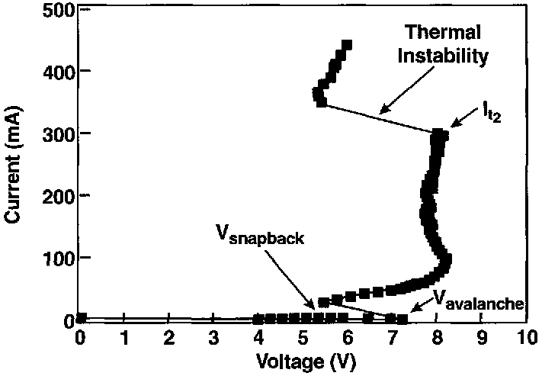
Fig. 1 TLP I-V characteristic of SiGe HBT device.

References: When citing references in the text, type the corresponding reference number at the end of the sentences in brackets followed by the punctuation [1]. Avoid using " Ref. [1]" or " reference [1]". At the beginning of a sentence use " Reference [1]…. ". Examples for a journal paper are given in the list of references.
Electronic Files: Electronic files of your submission should be supplied to the Conference Secretariat by E-mail (service@t-esda.org) or on a clearly labeled floppy disk. The file should be in Word or PDF format.

3. FURTHER INFORMATION

Questions concerning the preparation of papers should be addressed to the Conference Secretariat.

REFERENCES

- C. Duvvury, R. N. Rountree, and O. Adams, “Internal chip ESD phenomena beyond the protection circuit,” IEEE Trans. on Electron Devices, vol. 35, no. 12, pp. 2133-2139, 1988.
- M. D. Jaffe and P. E. Cottrell, “Electrostatic discharge protection in a 4-Mbit DRAM,” in Proc. of EOS/ESD Symp., 1990, EOS-12, pp. 218-223.
- M.-D. Ker and H.-H. Chang, “Whole-chip ESD protection for CMOS ICs using bi-directional SCRs,” US patent #6,011,681, Jan. 2000.

