Biography

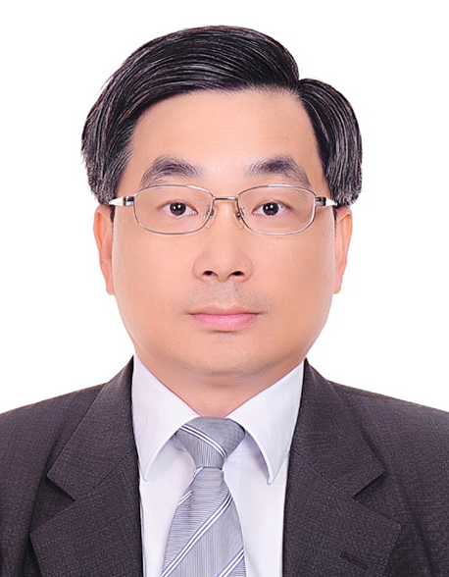
Ming-Dou Ker (S’92–M’94–SM’97–F’08) received the Ph.D. degree from the Institute of Electronics, National Chiao-Tung University, Hsinchu, Taiwan, in 1993.
He ever worked as the Department Manager with the VLSI Design Division, Computer and Communication Research Laboratories, Industrial Technology Research Institute (ITRI), Hsinchu, Taiwan. Since 2004, he has been a Full Professor with the Department of Electronics Engineering, National Chiao-Tung University, Hsinchu, Taiwan. During 2008 ~ 2011, he was rotated to be Chair Professor and Vice President of I-Shou University, Kaohsiung, Taiwan. Now, he has been the Distinguished Professor in the Department of Electronics Engineering, National Chiao-Tung University, Taiwan. He ever served as the Executive Director of National Science and Technology Program on System-on-Chip (NSoC) in Taiwan during 2010 ~ 2011; and currently serving as the Executive Director of National Science and Technology Program on Nano Technology (NPNT) in Taiwan (2011 ~ 2014). In the technical field of reliability and quality design for microelectronic circuits and systems, he has published over 450 technical papers in international journals and conferences. He has proposed many solutions to improve the reliability and quality of integrated circuits, which have been granted with hundreds of U.S. patents and Taiwan patents. He had been invited to teach and/or to consult the reliability and quality design for integrated circuits by hundreds of design houses and semiconductor companies in the worldwide IC industry. His current research interests include reliability and quality design for nanoelectronics and gigascale systems, circuit-related reliability issue, as well as the biomimetic circuits and systems for intelligent prosthesis.
Prof. Ker has served as member of the Technical Program Committee and the Session Chair of numerous international conferences for many years. He ever served as the Associate Editor for the IEEE Transactions on VLSI Systems, 2006-2007. He was selected as the Distinguished Lecturer in the IEEE Circuits and Systems Society (2006–2007) and in the IEEE Electron Devices Society (2008–2012). He was the Founding President of Taiwan ESD Association.

